Pythagorean Aspects of Music
by Stephen M Phillips

“In ancient times, music was something other than mere pleasure for the ear: it was like an algebra of metaphysical abstractions, knowledge of which was given only to initiates, but by the principles of which the masses were instinctively and unconsciously influenced. This is what made music one of the most powerful instruments of moral education, as Kong-Tsee (Confucius) had said many centuries before Plato.”
G. de Mengel, Voile d’Isis
1. Introduction
I shall explore in this article how the ‘harmonies of heaven’ manifest here on earth in our acoustic responses to different tunings. We are aware that Pythagoras was supposed to have discovered the mathematical basis of music, although the various legends surrounding his discovery of its laws probably contain little truth. But we are, perhaps, not aware that the Pythagorean theory of music was but one application of the principles of his holistic philosophy, which was not only a modus vivendi but a system of understanding the immanence of God in nature through the study of number. As part of a continuing programme of research into the connection between Pythagorean number philosophy and contemporary particle physics, I would like to set out here what I believe are some fruits of this work.
For some this may be a journey into an unfamiliar and abstract world, and I would fully understand if some readers lost their way as they followed my route. However, my analysis has to be mathematical because number is the ultimate language of logic. That said, I shall avoid using technical terms familiar only to a professional mathematician.
My initial discussion will centre on the geometrical figure called the tetrahedron. This solid shape has four corners and four equilateral triangles as its faces. It symbolized for the Pythagoreans the number 4, which will appear regularly in my analysis: we find it in the tetrachord and in the two ‘perfect fourths’ into which the ancient Greeks divided their musical scales. Most importantly, we find it in the tetractys, the sacred symbol of Divine Wholeness at the heart of the number philosophy of Pythagoras. We shall discover that it expresses the mathematical character of the various musical ‘modes’ that the Church adopted from ancient Greece. My research indicates that this is an example of a universal principle at work, prescribing the nature of physical and superphysical reality.
As most people’s hearing has been blunted by life-long exposure to equal-temperament, it is difficult for us now to recreate with ‘innocent ears’ the original musical experience of the Greek musical modes. My article will show, however, that they have far more significance than historians of music have considered. They exhibit a certain mathematical completeness and a beautiful symmetry and proportion that has its remarkable counterpart in a certain class of numbers that some physicists believe may describe the basic units of matter. In other words, vibration – whether it is of violin strings or string-like subatomic particles – may be governed by mathematically analogous laws: studying the proper (ie Pythagorean) mathematical basis of music may therefore give one insight into the ‘holy grail’ of physics, namely, the so-called ‘theory of everything’ that explains all the forces of nature. More important still, it may help us to understand our spiritual origins.
2. The Pythagorean Musical Scale
Music has four aspects: the physical (sound/wave vibration), the aesthetic (feeling/mood), the conceptual (theme/meaning) and the spiritual (abstract/ archetypal)[1]. This article will explore the lattermost facet, to which the quotation above refers.
To do this, we need to realize that a musical score really signifies a huge set of numbers — the frequencies of all its notes — and that a musical experience is determined partly[2] by what these numbers are and how the composer has ordered in time the playing of the notes. For, just as geometry is the study of number in space, so music is the study of number in time. The 12 tone octave in use today is a development of the ancient Pythagorean scale which consisted of 8 notes: C D E F G A B C'.
It is well-known how it came to be conceived by the early Pythagoreans. They knew that successive octaves C and C' are separated in pitch by a factor of 2. Assigning to the tonic C the frequency 1, the arithmetic mean[3] of 1 and 2 is 3/2, which is the tone ratio[4] of G, the perfect fifth, whilst their harmonic mean[5] is 4/3, the tone ratio of F, the perfect fourth.
As 4/3x3/2 = 2 = 3/2x4/3, the interval between the perfect fourth F and the octave C¹ is a perfect fifth, whilst the interval between the perfect fifth G and the octave is a perfect fourth. As 4/3x9/8 = 3/2, the interval between F and G is 9/8. This defines the Pythagorean tone interval.
If note D is a tone interval from C and if E is a tone interval from D, then the interval from E to F is 256/243 because 9/8x9/8x256/243 = 4/3. This interval between the third and fourth notes is the ‘leimma’ (leftover) or semitone. The pattern of intervals and leimmas from C up to F is repeated over another interval of a perfect fourth from G up to C'. G is the geometric mean[6] of F and A. The tone ratios of the seven intervals in the Pythagorean, diatonic scale are:
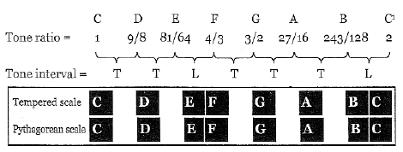
where T denotes a Pythagorean tone interval (about four cents[7] higher in pitch than the equal-tempered interval) and L is the leimma, which is about ten cents lower in pitch than the equal-tempered half-interval. Five tone intervals and two leimmas therefore span the Pythagorean octave.
Twelve intervals of a fifth are approximately equal to seven octaves, but are in reality slightly more than seven octaves, the discrepancy being the Pythagorean comma of 3¹²/2¹⁹, or roughly 74/73. As tone intervals are in the ratio 9:8, and leimmas are in the ratio 256:243, two leimmas are slightly less than one tone interval. In fact, the Pythagorean, Philolaus of Tarentum, noted that one whole note is equal to two leimmas plus a Pythagorean comma: 9/8 = 256/243x256/243x3¹²/2¹⁹.
3. The Tetrahedral Platonic Lambda
The Pythagoreans represented the numbers 1, 2, 3 & 4 by the ‘tetractys’:
1  2  3  4 | 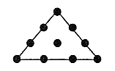
It was the cornerstone of their philosophy not merely (as most historians of Greek science believe) because it symbolised for the Pythagoreans the perfect number 10, or decad, but for the following, far more profound reason: as I have demonstrated in the context of particle physics,[8] the tetractys expresses the physical and superphysical wholeness of systems that actualize the 10-fold nature of Divine Unity in four stages denoted by the four rows of the tetractys.
This unitive state, which they called the Monad, corresponds in arithmetic to the number 1 (represented by the mathematical point), although for the Pythagoreans it was not a number per se but the metaphysical source of all numbers. The Monad is the undivided One described by mystics; the tetractys is its 10-fold differentiation to become the Many within the One.
Plato learnt much of his mathematics from the few books on Pythagorean philosophy that existed during his time.[9] In his Timaeus, Plato describes how, having blended the three ingredients of the World Soul — Sameness, Difference and Existence — into a kind of malleable substance, the Demiurge took a strip of it and divided its length into portions measured according to the simple proportions of the first three powers of 2 and 3.
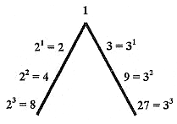
Fig.1. The Platonic Lambda
This became known as his ‘Lambda,’ so-called because of its resemblance to the Greek letter Λ (Figure 1). These numbers line two sides of a tetractys of ten numbers, from whose relative values the physicists and musicians of ancient Greece worked out the frequencies of the notes of the octaves of the now defunct Pythagorean musical scale.
The Table of Lambda (Figure 2), handed down to us by the Pythagorean mathematician and mystic, Nichomachus of Gerasa (fl. c. 100 CE), extends the numbers in the Lambda. The horizontal rows of integers in Figure 2 are geometric progressions by 2 and the rows descending diagonally are geometric progressions by 3. Consecutive numbers in vertical columns are to each other in the ratio 3/2, defining the perfect 5th, whilst consecutive, diagonally paired numbers (shown by arrows) are in the ratio 4/3, defining the musical fourth.
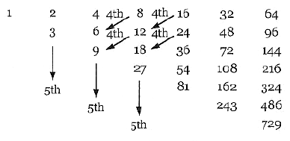
Fig. 2. The Table of Lambda
The tetractys of integers at the beginning of the Table of Lambda serves as the basis of musical harmony:
1  2  3  4 | 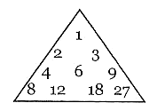
Using the octave of 6:12, their arithmetic mean is 9, which, in relation to 6, is in the ratio 3:2. This is the perfect fifth. The harmonic mean of 6 and 12 is 8. This proportion, 8:6 or 4:3, is the perfect fourth. But 12:9 is also 4:3, that is, a perfect fourth, whilst 12:8 is also 3:2, which is a perfect fifth. The ratio 9:8 defines a whole tone. The central integer, 6, which is absent from the set of integers (1, 2, 3, 4, 8, 9, 27) in Plato’s Lambda, is pivotal to discussion of the mathematical proportions of the musical notes for the following reason.
If the integer n is chosen as the fundamental frequency, then the first overtone, or octave, has a frequency of 2n. The harmonic mean of these integers is (4/3)n, which is the perfect fourth. The arithmetic mean of n and 2n is 3n/2, which is the perfect fifth. Because n has to be divisible by both 2 and 3, that is, by 6, both means are integers if n = 6N, where N is an integer, ie the smallest value of n defining integer values of both the perfect fourth and fifth is therefore 6. If the tonic has a tone ratio of 6N, then the perfect fourth has a tone ratio of 8N and the perfect fifth has a tone ratio of 9N, thereby defining a musical interval of 9/8.
If the Lambda and its underlying tetractys are regarded purely as a Pythagorean construction, then it is incomplete. This is because the numbers 1, 2, 3 and 4 were the basis of Pythagorean number mysticism (as exemplified par excellence by the tetractys) and its application to the study of natural phenomena such as the sounds made by vibrating strings, whereas the number 4 is missing as a generative factor from the Lambda, which uses only 1 (the monad), 2 (the dyad) and 3 (the triad) to generate its numbers.
Figure 3 shows how the Pythagorean wholeness of the Lambda is restored naturally by realising that it is but two edges of a tetrahedron having 1 at its apex and a third edge with the first three powers of 4 arranged along it.
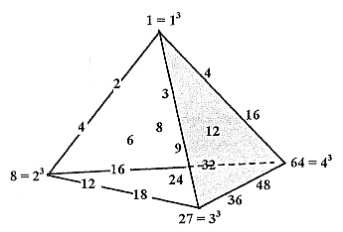
Fig.3.
The resulting set of 20 numbers has the following musical virtue: the Table of Lambda generates the tone ratios of octaves along one side and perfect fifths along another side. But the numbers starting with 6 and generating the perfects fourths have to be added by hand, so to speak, following ad hoc rules of multiplication by 2 and 3 that were not part of Plato’s cosmological theory and whose justification is merely that they conform to the same pattern of multiplication. In Figure 3 we see moreover, that whereas the pairing of numbers separated by octaves or intervals of the perfect fifth follows the natural geometry of the array of numbers set by the extended boundary of the Lambda, the pairing of successive perfect fourths does not respect the same symmetry because it occurs in diagonal fashion across the array. Worse still, the other possible diagonal pairing of numbers whose tone ratios differ by a factor of 3 plays a relatively weak role in generating twelfths of the diatonic scale. The traditional construction of the tone ratios of the diatonic scale clearly lacks symmetry. This is because the classical scheme is mathematically incomplete.
In Figure 4, on the other hand, the fourth face of the tetrahedron is a tetractys of numbers whose pairings parallel to its three sides create octaves, perfect fifths and perfect fourths with, respectively, the tone ratios, 2/1, 3/2 and 4/3. The hexagonal arrangement of these pairings means that, when extended in the manner of the Lambda tetractys forming the first face of the tetrahedron, every number becomes surrounded by six others that are octaves, perfect fourths or perfect fifths. Parallel lines of successive octaves are at 120° to parallel lines of successive perfect fourths, which in turn are at 120° to parallel lines of successive perfect fifths.
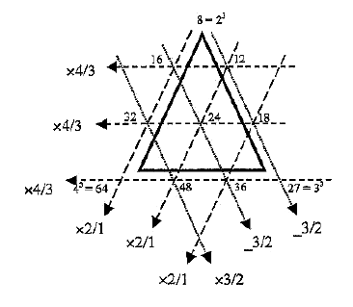
Fig.4.
The integers 6, 8, 12 & 24 at the centres of the four faces of the tetrahedron are in the ratio 1:4/3:2:4, ie if 6 corresponds to the tonic with tone ratio 1, then the number 24 at the centre of the fourth face defines the tone ratio 4 of the second octave. Through these centres, the tetrahedron defines the 15 notes spanning two complete octaves. We shall return later to the musical significance of this.
Figure 5 displays the lattice of tone ratios, starting with 1, the fundamental, that are created by dividing the numbers in Figure 4 and their higher octaves by any one of them. The same infinite lattice of tone ratios results, whichever number is chosen, because the perfect symmetry generated by each number being an arithmetic, harmonic or geometric mean of its neighbour favours no particular number.
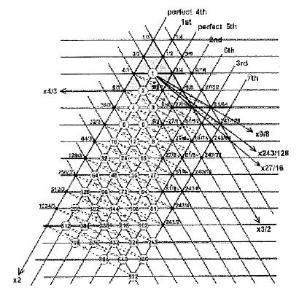
Fig.5. Generation of the tone ratios of successive octaves of the Pythagorian Scale
Overtones are shown in circles, lines sloping towards the right connect octaves (x2), horizontal lines connect perfect fourths (x4/3) and lines sloping towards the left connect perfect fifths (x3/2). The dashed line connects successive notes of each octave. It zigzags between octaves, thirds, fourths and sevenths, ie between the extremities of the scale and its midpoint.
Figure 6 displays the remarkable, mathematical harmony of the Pythagorean scale. Each tone ratio is the arithmetic, harmonic or geometric mean of its nearest neighbours (indicated by single or double-headed arrows).
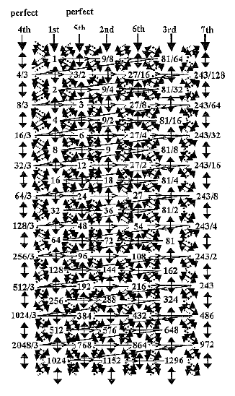 | 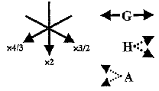  G = geometric mean  H = harmonic mean  A = arithmetic mean
 | Fig.6.
As in Figure 4, successive notes of the scale for each octave are joined by lines that zigzag through the corners and centres of sets of three joined hexagons, successive sets overlapping corner to centre:
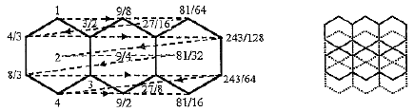
This hexagonal pattern depicts the notes of the Pythagorean scale in a more symmetric way than the Table of Lambda in Figure 2. But why should this beautiful proportion exist in a musical scale that was discarded when musicians found that they could not tune their instruments to it? Could it be that a musical scale based upon such mathematical harmony actually has another relevance in Nature? Indeed. My research [10] has proved that this mathematical pattern is not confined to music but applies also in the subatomic world to the vibrations of what physicists call “superstrings.”
4. The Seven Greek Musical Modes
Evolution is perceived today as proceeding inwardly from the material to the spiritual world or, according to Darwinian biology, as traversing the planet from one species to another by accident and without purpose. According, however, to ancient Greek thinking, man had descended from the Gods. This fundamental difference in how they saw their place in the universe was reflected in the way they regarded the musical scale. Instead of considering, as musicians do now, the notes of the major scale: do, re, mi, fa, sol, la, ti, do, as ascending in pitch, the Greeks thought in terms of a descending scale, with its eight notes divided into two sets of four notes, or ‘tetrachords.’
The most important note in a scale was the μεοη (mesê, or middle note) which was the highest note of the lower tetrachord. [11] It set the quality of music played according to a particular scale because it was often the most played of the notes. The Pythagoreans compared its position to that of the sun amidst the planets: it held the melody together as its fulcrum. Altering the sequence of whole tones and semitones within a tetrachord generated different scales.
Seven distinct scales or modes came to be recognised, although this is a simplification, as variations of these were known: Bishop Ambrose of Milan codified and simplified them in the 4thC into four ‘authentic modes.’ To these Pope Gregory used the writings of the medieval musical theorist, Boethius, to add four ‘plagal’ modes. Their ecclesiastical names, ascending from C, are: Ionian, Dorian, Phrygian, Lydian, Mixolydian, Aeolian and Locrian (the eighth was the Phrygian with a different tonic and dominant).
They were named not after their first or last notes (being sequences of descending notes, tonics within these scales were not definable) but after the various peoples of ancient Greece who were reputed to have preferred one mode to another, depending on their character and temperament. Ancient Greeks were very familiar with the distinct qualities of melodies played according to some of these modes and the psychological effects they had on those listening to them.
The following story illustrates this: according to his biographer Iamblichus,[12] Pythagoras devised melodies to heal the soul by soothing its passions and cleansing it of negative conditions such as sorrow, rage, pity and anger. He would play this music to his disciples as they prepared for bed in order to remove all the emotional disturbances they had acquired during the course of the day. When they woke up the next morning, Pythagoras freed them from the heaviness and torpor of their sleep by certain kinds of singing and playing of the lyre.
Iamblichus tells the story of how a young man, angered by seeing his girl-friend leave the house of his rival, had eaten and drunk all night, his jealousy inflamed by a piper playing Phrygian music, which made him unable to resist his impulses. Pythagoras persuaded the piper to play slow and heavy spondaic music probably of the Dorian mode, which had the effect of restraining and calming the man,[13] who returned home in a sober and orderly fashion.
Whether this tale is true or not (and one must bear in mind that Iamblichus was wont to glorify his hero by passing off as factual all the legends surrounding him), it serves to illustrate the belief in ancient Greece that music based upon their musical modes could transform the behaviour of the hearer in positive or negative directions; the music of some modes was thought to be character-building, whilst that of others led it astray. Plus ca change, plus c’est la meme chose!
Plato had strong views about the rightness and wrongness of various modes. In his Republic, which sets out his ideas about an ideal society, he advocated only the Dorian and Phrygian modes. In referring to the Lydian, Plato regarded it as a "mixed" mode, seeing a distinction between the “tight” Lydian (by which he refers perhaps, jokingly, to the upper tetrachord) as “wailing modes” suitable for women, whilst the “slack” Lydian (perhaps the lower tetrachord or Hypolydian) and the Ionian he thought encouraged drunken-ness, softness, and idleness. He probably meant his words to be a joke for his readers because certain strings were tight for some modes and slack for others, whilst he also meant the word ‘tight’ to indicate that the mode reached into higher notes that put a strain on the male voice and altered its quality, whereas in the slack Lydian mode the melody stayed more in the lower part of the octave.
Plato makes Socrates remark: “Just leave that mode which would appropriately imitate the sounds and accents of a man who is courageous in warlike deeds and every violent work, and who in failure or when going to face wounds or death or falling into some other disaster, in the face of all these things stands up firmly and patiently against chance. And, again, leave another mode for a man who performs a peaceful deed, one that is not violent but voluntary, either persuading someone of something and making a request –whether a god by prayer or a human being by instruction and exhortation– or, on the contrary, holding himself in check for someone else who makes a request or instructs him or persuades him to change, and as a result acting intelligently, not behaving arrogantly, but in all these things acting moderately and in measure and being content with the consequences.
“These two modes — a violent one and a voluntary one, which will produce the finest imitation of the sounds of unfortunate and fortunate, moderate and courageous men — leave these.”[14] The modes referred to here are the Phrygian and the Dorian. Aristotle[15] declared Socrates to have been wrong in including the Phrygian mode for an ideal state, for the exciting, emotional quality of its melodies made it apt for Bacchic celebrations.
Plato might have been expected to deprecate this aspect but, surprisingly, he ignored it. Perhaps the Phrygian mode had other qualities that he esteemed sufficiently not to reject it. More likely, however, there was a variety of Phrygian modes, not all of which were associated with orgiastic cults, and one of them met Plato’s approval.
One of the most widely used modes in the 5thC BCE and probably earlier, the Dorian was always well regarded. It was a versatile mode, often employed for choral song but not confined to it, and compatible with more than one mood. On the whole, however, it was regarded as dignified and manly. Aristotle said that “everyone agrees that it is the steadiest and the one that most has a manly character.”[16] It is mentioned in The Hymns of Orpheus, a great poetic work of ancient Greece:
’Tis thine all Nature’s music to inspire,
With various-sounding, harmonising lyre;
Now the last string thou tun’st to sweet accord,
Divinely warbling now the highest chord;
Th’immortal golden lyre, now touch’d by thee,
Responsive yields a Dorian melody. [17]
Plato wanted to eliminate from his ideal society the Lydian mode as emotional, fit only for tragedy, as was deemed the Mixolydian. Indeed, Sophocles introduced it to his plays for this very reason. However, in his book Music in Ancient Greece and Rome, Landels remarked: “One suspects that Plato is being a bit puritanical here, as the Mixolydian is described elsewhere as combining (hence the prefix Mixo-) the emotional quality of the Lydian with the nobility of the Dorian, and therefore being suitable for tragedy.”[18]
The Hypodorian and Hypophrygian modes were not identified under these names before the late 5th or early 4thC BCE. The music scholar M.L. West conjectured[19] that the Hypolydian was an invention of Eratocles, who enumerated the seven species of the octave in one genus, devising the name for the sake of parallelism, so that Lydian, Phrygian and Dorian each had a corresponding Hypo- species starting on the note a fourth higher in the scale. There were several rival schemes of classification, with general agreement only on the sequence: Dorian, Phrygian and Lydian. As will be discussed shortly, the confusion caused Aristoxenus to base modal scales on keys rather than consider them as octave species, using the seven names that Eratocles had applied to his octave species. This purely musical emphasis prevailed, with the consequence that the mathematical nature of the unfolding of the modes ceased to be of interest to anyone. Music had passed out of the hands of mathematicians and philosophers looking for divine design (and perhaps divine inspiration) in music and had become the practical business of musicians more concerned with how to tune their instruments properly so as to play music that just entertained, rather than melodies that could heal and elevate the soul.
In antiquity there seems to have been general agreement on the sequence: Dorian, Phrygian, Lydian, but only partial agreement about others. This caused Aristoxenus to disregard the Pythagorean basis of the musical scale by adhering to the simple rule that a fourth is 2.5 tones and that all intervals must be measured in tones and fractions of a tone. For some years a pupil of Aristotle, Aristoxenus no doubt shared his teacher’s rejection of Pythagorean principles in general and the Pythagorean basis of music in particular. He worked out a system of melodic scales based not on modalities but on keys — thirteen of them in fact, arranged at regular semitone intervals over a whole octave. He did not refer to the seven species of scale by their modal names, although he adopted existing nomenclature to name them. Aristoxenus added an eighth scale above the Mixolydian to complete the octave, calling it the Hypermixolydian. Later, his system was reformed to that of a 15-key system.
Both were criticised eventually (although to no avail, as the latter had already become firmly established) by the musical theorist Ptolemy, who (rightly) condemned the completion of the octave with the Hypermixolydian as mere duplication.
5. The Tonal Structure of the Modes
Historically speaking, musical scales were always divided into eight notes because the ancient Greeks regarded them as composed of two tetrachords, which were together known as the diapason, or full range, a term preserved in the English organ stop of the same name. Because the musical scale is based entirely on octaves and fifths, that is, two notes, it is called the ‘diatonic scale.’ As we have seen, it comprises five tone intervals of 9/8 and two smaller intervals, or leimmas, of 256/243. Its tone interval structure is:
C D E F G A B C¹
tone – tone – leimma – tone – tone – tone – leimma.
Seven (and only seven) musical scales[20] can be generated by successive translations of a diatonic interval (T) or leimma (L):
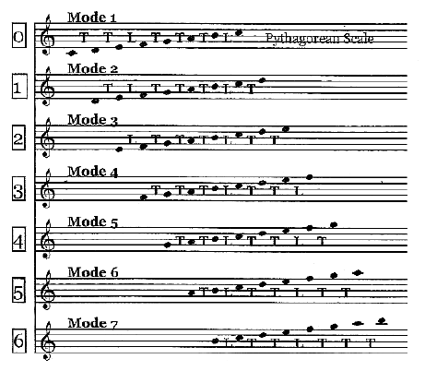
(Numbers 1–6 indicate the number of translations). There are no more than seven distinct sequences because the scale created by shifting Mode 7 by an interval creates the interval pattern: T T L T T T L, which is Mode 1. It does not matter where in the infinite sequence of successive intervals of the ascending Pythagorean scale: … T L T T T L T T L T T T L T T L T T T …
a starting point is chosen for a sequence of seven successive intervals and then shifted upwards in pitch by an interval or leimma, for this translation will always generate one of the patterns of intervals of the seven scales.
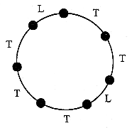
Fig.7. The seven intervals of the Pythagorian Scale
Figure 7 demonstrates this by representing the seven intervals of the Pythagorean scale by arcs of a circle. The smaller arc denotes the leimma (L) and the larger one denotes the tone interval (L). Wherever one starts — indeed, whether the selection is made in a clockwise direction (increasing pitch) or an anticlockwise direction (decreasing pitch) — there are seven, and only seven, different patterns of Ls and Ts that can be chosen sequentially before one arrives back at the interval from where one started. Whether one starts with a sequence of descending or ascending notes, successive transpositions generates the same set of seven patterns of intervals. When they start with the same note, these patterns become the seven Greek musical modes. Just as a Pythagorean musical scale is a cycle of seven intervals, each successive octave being a repetition of this cycle, so, too, the seven modes constitute a cycle comprising 13 intervals (9 tone intervals T and 4 leimmas L) and 14 of the 15 notes spanning two complete octaves. The difference in pitch between their lowest and highest notes is 243/64 = (3/2)⁵/2, ie an octave below the fifth perfect fifth, which has a tone ratio of (3/2)⁵.
Mode | C | D | E | F | G | A | B | C¹ | Non-  diatonic  notes
Mode 1 | 1 | 9/8 | 81/64 | 4/3 | 3/2 | 27/16 | 243/128 | 2 | 0
Mode 2 | 1 | 9/8 | 32/27 | 4/3 | 3/2 | 27/16 | 16/9 | 2 | 2
Mode 3 | 1 | 256/243 | 32/27 | 4/3 | 3/2 | 128/81 | 16/9 | 2 | 4
Mode 4 | 1 | 9/8 | 81/64 | 729/512 | 3/2 | 27/16 | 243/128 | 2 | 1
Mode 5 | 1 | 9/8 | 81/64 | 4/3 | 3/2 | 27/16 | 16/9 | 2 | 1
Mode 6 | 1 | 9/8 | 32/27 | 4/3 | 3/2 | 128/81 | 16/9 | 2 | 3
Mode 7 | 1 | 256/243 | 32/27 | 4/3 | 1024/729 | 128/81 | 16/9 | 2 | 5
Table 1. Tone ratios of the 56 notes in the seven Greek Modes
Grey cells contain tone ratios not belonging to any octave of the diatonic scale. The table shows that Mode 1 is unique in that it encompasses all the notes of the Pythagorean scale (no grey cells).
There are 16 (=4²) such tone ratios. The 49 notes of the 7 modes other than octaves C¹ comprise (49-16=33) diatonic tone ratios, of which seven are 1s, leaving (33-7=26) such tone ratios other than 1. 26 is the sum of the number of combinations of ten objects H, I, J, etc arranged in the four rows of a tetractys and 33 is the total number of their permutations:
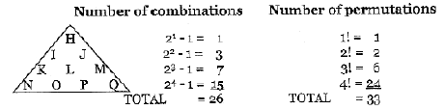
The presence of these two numbers[21] in the context of the seven Greek musical modes is no coincidence but reveals the fundamental role of the tetractys in expressing the mathematics of music. Indeed, those tone ratios other than 1 that occur more than once in the seven modes themselves form a tetractys:
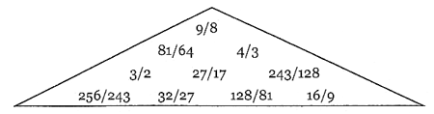
The six tones above the tonic of Mode 1 occupy the first three rows of this tetractys and the four non-diatonic tone ratios above the tonics of four other modes that occur more than once occupy its fourth[22] row.
The even integers 2 and 4 and the odd integers 1, 3 and 5 in Table 2 measure the deviation of the six non-Pythagorean modes from the perfection of the Pythagorean scale because they are the numbers of tone ratios not belonging to the diatonic scale (Figure 8). Notice how, starting from Mode 7, the most imperfect mode with five non-diatonic notes, there is an oscillation between modes with even and odd numbers of such notes as they develop into the perfect Mode 1 with no non-diatonic notes.
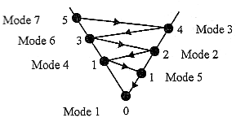
Fig.8. The convergence of the Greek musical modes
to the perfect Pythagorian scale
Although, according to Table 1, both Modes 4 and 5 contain the same number of diatonic notes, it can be argued that the latter is less perfect than the former because it does not contain a perfect fourth. It is for this reason that Mode 5, rather than Mode 4, is shown in Figure 8 as the penultimate stage in the cycle of completion of the perfect Pythagorean scale.
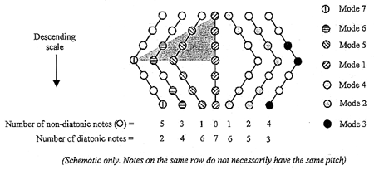
Fig.9. Numbers of diatonic and non-diatonic notes
in the Greek musical modes
Figure 9 shows how the Pythagorean character of the modes increases as they converge to the perfect Pythagorean scale. The ancient Greeks regarded all scales as descending and as composed of two tetrachords of four notes, their mesê being the highest note of the second tetrachord. Figure 9 indicates that the first tetrachord of Modes 7, 6, 5 & 1 comprise, respectively, 1, 2, 3 & 4 notes of the diatonic scale (shown encompassed by the grey triangle). The geometric symbol of Divine Wholeness — the tetractys, which symbolises these integers, therefore expresses the progression of musical modes to their perfection in the fourth, the Pythagorean scale.
This is another example of the ‘Tetrad Principle’ referred to earlier, whereby an infinite sequence of a class of mathematical objects finds its completion and perfection in its fourth member, which means that it always embodies a number characterising the cosmos in some way. Here, the Tetrad Principle determines the Pythagorean scale — the original basis of music itself — as the fourth of the musical modes. Another example of this principle at work prescribing the arithmetic properties of the seven modes is that the (7?8 = 56) notes of the seven octave scales (7 = 4th odd integer, 8 = 4th even integer) contain (4² = 16) non-diatonic note and (56 - 16 = 40) diatonic notes, where
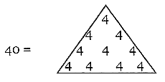
When their tonics (and therefore octaves) coincide, the 56 notes become (1+7?6+1=44) notes, showing how 4, the Pythagorean tetrad, aptly expresses the very number of notes in the seven modes when they start and end on the same notes! Some of the notes between their tonic and octave are, of course, the same.
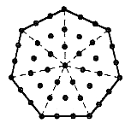 | • = tonic
Fig.10. A heptagon constructed from tetractyces
has as many dots surrounding its centre as the seven
Greek modes have notes other than their tonics
Of these, 16 are non-diatonic, leaving (44-16=28) that are diatonic, where
28 = 1 + 2 + 3 + 4 + 5 + 6 + 7
= 1 + 2 + 4 + 7 + 14
is the second perfect number.[23] Also, 28 = 4?7, where 7 = 4th odd integer. The modes with the same tonic have 43 notes other than their common octave.
This is the number of dots in a heptagon divided into tetractyses. In Figure 10 the dot at its centre shared by the seven tetractyses symbolises the tonic common to all seven modes and the six dots per tetractys denote the six other tones of each mode.
Finally, as illustration of the Tetrad Principle, notice that the seven modes descend from the second octave with tone ratio 4, which is both the fourth harmonic and the (4² = 16)th note. This provides new insight into the tetrahedral generalisation of the Platonic Lambda tetractys, for this is but one face of a tetrahedron (Figure 3) whose fourth face generates the octaves, their perfect fourths and perfect fifths in a symmetrical way. The musical proportions at the centres of its faces are 6, 8, 12 and 24. 6 is the musical proportion of the tonic of the diatonic scale, whose mathematical structure is determined by the equation of proportion between its tonic, perfect fourth, perfect fifth and octave that is known to every student of music: 6:8::9:12.
Relative to the tonic, the musical proportion 24 represents the second octave with tone ratio 4. In other words, this tetrahedron defines through its first and last faces the two octaves with 15 notes spanned by the seven Greek modes. In accordance with the Tetrad Principle, it is the fourth face of the tetrahedron whose central number defines something of fundamental musical significance. In fact, 15 is the total number of ways of grouping four objects either singly, in pairs, in groups of three or as a group of four:
⁴C₁ + ⁴C₂ + ⁴C₃ + ⁴C₄ = 4 + 4 + 6 + 1 = 15. [24]
It is therefore the number of corners, edges, triangles and tetrahedra in this Platonic solid. The tetrahedron of musical proportions can be said not only to generate the notes of the diatonic scale but also to define in potential the seven Greek modes themselves.
It is sometimes a shock to musicians to learn that the names of the Church modes that they became familiar with during their studies are incorrect. Confusion in nomenclature persists to this day. It arose from the Church’s taking over ancient Greek names on the assumption that they referred to ascending scales, whereas in fact the Greeks always regarded scales as descending. We do not know what the interval structures of the various scales were, although there is agreement on the sequence: Dorian, Phrygian and Lydian.
As was shown earlier, the same set of patterns of intervals results whether an ascending or descending Pythagorean scale is considered. However, when individual scales are named, the particular assignment of these names will depend on whether the notes are regarded as ascending or descending. This is illustrated in Figure 11 (below). The interval patterns of the seven Church modes (written in brackets) are indicated in an upward, staggered sequence. Suppose they are assigned the ‘ancient Greek’ names shown (the actual ones used is irrelevant for the present purpose). If, keeping the ordering of interval patterns the same, they had been correctly considered as descending in pitch, the names would have been re-ordered to that shown in the upper half, although the relative ordering would have been unchanged. But what, say, the Church called the ‘Lydian’ (TTTLTTL) should really have been what it called the ‘Locrian’ (LTTLTTT) because the intervals should have been regarded as descending, not ascending. To obtain the correct name for a given Church mode, one has to reverse its interval pattern and assign to the new pattern whatever is the name agreed by musical scholars. The names given in Figure 11 agree with the 1998 edition of Encyclopaedia Britannica.
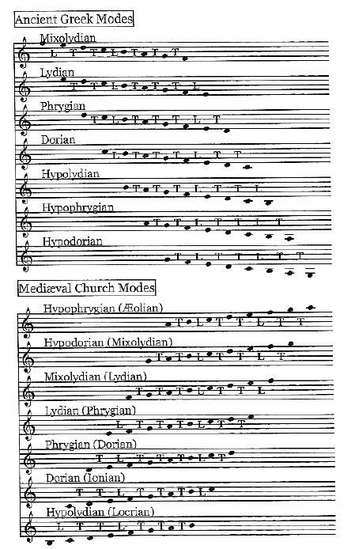
Fig.11.
As proof of the incorrectness of the names of the Church modes, compare the inconsistent statements of Aristotle (384-322 BCE) and Odo, Abbot of Cluny (d. 942) regarding the Mixolydian mode:
Aristotle (Politics): “The musical modes differ essentially from one another, and those who hear them are differently affected by each. Some of them make men sad and grave, like the so-called Mixolydian; others enfeeble the mind, like the relaxed modes; another, again, produces a moderate or settled temper, which appears to be the peculiar effect of the Dorian; and the Phrygian inspires enthusiasm.”
Cluny: “Both in its original seat, and when transposed, it breathes majesty, boldness, and joy, such as might fitly become the celestial hierarchy in their ‘Gloria in excelsis’ when the ‘Christ the Lord’ was born in Bethlehem.”
The Dorian mode favoured by Plato for teaching music to the youth of his ideal state is the Pythagorean scale. It alone is mathematically complete and perfect.
6. Pitch Differences between Modes & Equal-tempered Scale
The Pythagorean scale is divided into seven intervals, five of which are whole tones differing in pitch by 9/8 and two of which are leimmas, differing in pitch by 256/243. In the modern equal-tempered scale the scale is divided into twelve semitones separated by equal intervals, so that two semitones are together equal to one tone. This means that the difference in pitch between successive, equally tempered semitones = 2^{1/12} and that the difference in pitch of a tone interval = 2^{1/12}x2^{1/12} = 2^{1/6}. The tone ratios of the notes in this scale corresponding to those in the diatonic scale are:
C D E F G A B C-
1 2^{1/6} 2^{1/3} 2^{5/12} 2^{7/12} 2^{3/4} 2^{11/12} 2
The difference in pitch between two notes separated by a semitone is defined as 100 cents. This means that an octave spans 1200 cents because it spans 12 semitones. Two notes with pitches f₁ and f₂ separated by n semitones will have pitches in the ratio f₂/f₁ = 2^{n/12}, that is, they differ by 100n cents. Therefore, n = 12log₂(f₂/f₁), that is, their pitch interval in cents = 1200log₂(f₂/f₁). Noting that log₂Xxlog₁₀2 = log₁₀X,[25] where X is any positive number, their pitch interval = (1200/log₁₀2)log₁₀(f₂/f₁) ≈ 3986.3log₁₀(f₂/f₁).
This formula may be used to calculate the pitch differences in cents between the notes of the seven modes and their corresponding notes in the equal-tempered scale.
Mode | C | D | E | F | G | A | B | C¹
Mode 4 | 0 | +4 | +8 | +112 | +2 | +6 | +10 | 0
Mode 3 | 0 | -110 | -106 | -2 | +2 | -108 | -104 | 0
Mode 2 | 0 | +4 | -106 | -2 | +2 | +6 | -104 | 0
Mode 1 | 0 | +4 | +8 | -2 | +2 | +6 | +10 | 0
Mode 7 | 0 | -110 | -106 | -2 | -112 | -108 | -104 | 0
Mode 6 | 0 | +4 | -106 | -2 | +2 | -108 | -104 | 0
Mode 5 | 0 | +4 | +8 | -2 | +2 | +6 | -104 | 0
Table 2 above shows in cents the difference: modal note pitch - equal-tempered note pitch. Table 3 below shows the notes corresponding to these values.
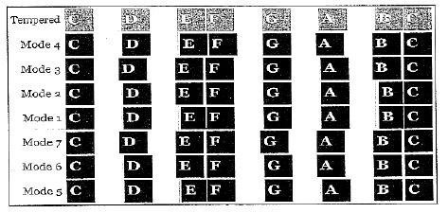
As a comparison, the Pythagorean tone interval 9/8 is 204 cents, slightly larger than the equal-tempered tone interval of 200, and the leimma is about 90 cents, lower than the semitone of 100 cents. 21 of the 42 notes between the tonic and the octave are higher in pitch than their counterparts in the equal-tempered scale and 21 are lower in pitch (Figure 12).
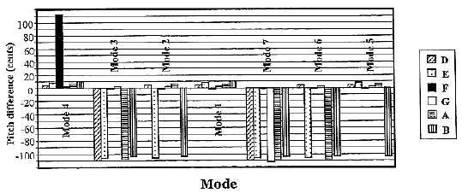
Fig.12. Pitch differences between the notes of the seven modes
and their equal tempered counterparts
The Dorian mode is closest in pitch to the equal-tempered scale, or rather it ought to be said that this artificial scale is nearest the mathematically perfect Pythagorean scale compared with the other modes. With variations of pitch between 2 and 10 cents, the two are virtually indistinguishable to most ears, at least for single notes — chords can be another matter. Over the frequency range most common in music (500 Hz to 4,000Hz), the ear can just detect an interval of less than one-thirtieth of a semitone, ie about three cents.[26] But it is harder to detect differences of pitch in real life than in the laboratory, and sensitivity falls below 500 Hz, dropping to about 30 cents at a frequency of 62 Hz. On the other hand, differences of pitch are easier to detect in musical sounds than in pure tones. All the notes of Mode 1 except the perfect fourth are slightly higher in pitch than the modern scale. But all 16 non-diatonic notes differ sufficiently to be differentiated. 15 of them are lower in pitch than their equal-tempered counterparts. Mode 4 is the only one whose notes are all lower in the equal-tempered scale, the fourth being more than a semitone lower (112 compared with 100). Mode 7 is the only mode whose notes in the modern scale are all higher than their classical counterparts, five of the seven notes being more than a semitone higher. Melodies played in modes other than Mode 1 (the Dorian) on instruments tuned to the modern scale will sound differently to their playing according to their pure pitches. Plato would have approved the modern major scale at least musically (if not mathematically) speaking because it most approximates the mode favoured by him as the ideal one! It must not, however, be forgotten that it is only an approximation, albeit a good one.
7. Mirror Symmetry of Modes
The ancient Greeks thought in terms of descending musical scales. As we have seen, the issue of whether the modes should be generated from ascending or descending notes does not arise. It is only we humans who, finding it easier to think in terms of increasing, rather than decreasing, numbers, wonder whether the modern view of the musical scale as ascending might be incompatible with its mathematical basis. Another reason for this is as follows: writing the Pythagorean whole tone interval 9/8 as T and the Pythagorean leimma 256/243 as L and taking in turn successive intervals (not notes) between the tonic and the octave of the Pythagorean scale (the true Dorian mode), the seven modes ascending in pitch from left to right are:
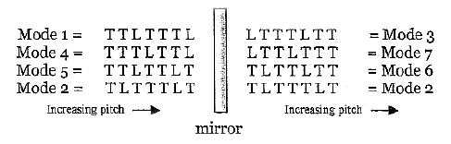
Notice that: 1. the order of tone intervals in Mode 3 is the mirror image or reverse of that of Mode 1 (Dorian), 2. Mode 4 is the reverse of Mode 7, 3. Mode 5 is the reverse of Mode 6, and 4. Mode 2 is unique among the seven modes in that the orderings of its ascending and descending tone intervals are the same — it is its own mirror image.
What does this reflection symmetry between pairs of modes (or within itself, in the case of Mode 2) imply? As only the relative ordering of tone intervals and leimmas defines the differences between the seven modes, not the absolute values of the pitches of their notes, it means that, if we started at any note of any mode and selected successive sets of descending notes with tone intervals of either 1/T or 1/L, we would get precisely the same sets of combinations of descending tone intervals as that shown above for the ascending notes. It makes no difference whether we regard the scales as descending (as the ancient Greeks did) or as ascending (as musicians do now). This is because the seven descending modes are, in terms of the patterns of their tone intervals, the very same as the seven ascending ones, the remarkable mirror symmetry displayed by their sets of tone intervals generating seven, and only seven, different ways of ordering them.
Each mode turns into another one (its mirror reflection) whilst Mode 2 turns into itself. The difference between the descending and ascending patterns is one of reflection of the order of tone intervals.
The descending Dorian: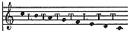
is like the ascending Mode 4: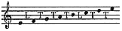 and vice versa
the ascending Mode 4: 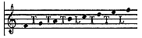
is like the descending Mode 7: 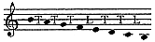 and vice versa,
and the ascending Mode 5: 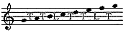
is like the descending Mode 6: 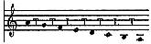 and vice versa.
One could say that the members of each pair are polar opposites, moving in opposite directions of pitch but similar in the ordering of their two types of intervals.
The seven Greek modes therefore consist of three such chiral pairs, one the mirror reflection of the other, and one (Mode 2) that is invariant with respect to reversing its tone intervals. This can be represented by a hexagon with polar opposite pairs at diametrically opposite corners and the mirror-symmetric Mode 2 at its centre:
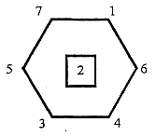
As well as turning into one another by mirror reflection of their tone intervals, the seven modes are generated by successive translations of a Pythagorean interval or leimma shifted upwards or downwards in pitch by an interval, for this translation will always generate one of the patterns of intervals of the seven musical modes (see Figure 11). This is because the endless sequence of intervals of the Pythagorean musical scale has the very important property of being its own mirror image. The infinite sequence of Pythagorean intervals is composed of repeated cycles of seven sets of seven intervals because, when Mode 7 is translated by one interval, it becomes Mode 1, further, successive translations merely repeating the cycle.
The cyclic nature of the interval structure of the seven modes is best illustrated by a circle with seven points denoting the modes equally spaced along its circumference:
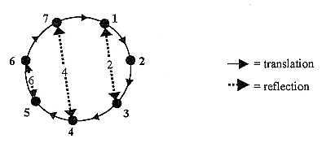
The polar opposite Modes 1 and 3 turn into each other by one reflection (denoted by the double-headed, dotted line arrow) or two successive, interval translations (denoted by solid line arrows). Modes 7 and 4 change into each other by one reflection or four successive translations. Modes 6 and 5 turn into each other by one reflection or six translations. An even number of translations creates a reflection.
Figure 13 shows how the T/L interval structure of the seven modes with the same tonic and octave can be mapped by representing their 44 notes as points on three great circles that are 60° apart and intersect at the South Pole (tonic) and North Pole (octave) of a sphere. The longer arcs denote Pythagorean tones (T) with an interval of 9/8 and shorter arcs signify leimmas (L) with an interval of 256/243. As the reflection of Mode 1, Mode 3 spans a semicircle (solid line) opposite that spanned by the former scale. Its second note is diametrically opposite the penultimate note of Mode 1, its third note is diametrically opposite the sixth note, and so on. Similarly, the notes and intervals of the mirror image Modes 4 and 7 are diametrically opposite one another on another great circle (dotted line), as are the notes of the mirror image Modes 5 and 6 lying on the great circle made up of dashes and dots. The notes of Mode 2 are situated at points that are mirror images of one another along the vertical axis of the sphere connecting its poles.
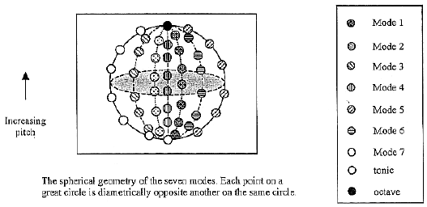
Fig.13.
Each of four modes (2, 3, 6 & 7) has four intervals that are different compared with those of Mode 1; two modes (4 & 5) have two intervals out of place with respect to this mode. We found earlier that Modes 4 and 5 each has one non-diatonic note. These two modes therefore most resemble Mode 1, which is what the ancient Greeks knew as the Dorian mode. Accordingly, the psycho-spiritual quality of music based upon them may be expected to be closer to that of the Dorian than the other four modes.
Conclusion
For many people, the fact that the tetrahedral generalisation of the Platonic Lambda generates the tone ratios of the Pythagorean musical scale will be merely a mathematical curiosity without even fundamental significance, let alone, spiritual meaning. This is because their denial of the metaphysical, or archetypal, origin of concepts makes them unable to recognise universal patterns as such linking the particulars.
For a Pythagorean, the connection between music and the tetractys (as we have seen, so much more than a mere symbol of the integers 1, 2, 3 & 4) has a more profound implication. It demonstrates the universal applicability of the sacred tetractys not only as an abstract representation of the ten-fold nature of Divinity but also as a pattern that actually prescribes our musical experiences, although only indirectly and faintly now through the equal-tempered scale. For this potent symbol transcends fleeting, cultural paradigms and man-made theologies. It expresses the ten-fold nature of Divine Immanence in the phenomenal world, as particle physicists working on the theory of superstrings have unconsciously revealed in their discovery that space-time must be ten-dimensional.
Just as mathematics is the language of the Divine Mind in which, as Galileo said, the book of Nature is written, expressing all possible states of the physical world, so music is the natural language for expressing all the states of the soul. Its mathematical composition must therefore reflect the similar, perfect harmony of the soul. Because the seven notes of the Pythagorean scale and the seven Greek musical modes are the exact, musical counterpart of a universal (that is, cosmic) principle that leads, among other things, to a seven-fold spectrum of consciousness in all life, melodies played according to them have qualities that must resonate in the awareness of the hearer, in whom these states exist. There must be in fact a correspondence between the psychological qualities of music played according to each mode and these seven, primary modes of consciousness.[27] This would help to explain why simply varying the positions of their half-intervals creates Church modes with such different characters and moods.
The highest function of music is not to entertain but to transform and refine all the subtleties of awareness— to invoke a consciousness of and ease accessibility to all the levels of one’s being and its infinite variation. Because the modern, equal-tempered scale does not reproduce the exact, tonal frequencies of the Pythagorean scale, contemporary and classical music cannot have the power of, say, the music used during the rites of ancient Mystery religions like Orphism to resonate with different levels of human consciousness and to transport the hearer to the celestial heavens. Only such pure sounds could be recognised and responded to at some subtle level of the psyche through the working of a principle of sympathetic resonance. This is not to say that equal-tempered music cannot induce epiphany — it can and does, but perhaps only when composed with the artistic genius of a Mozart or a Bach and for fundamentally different reasons.
A sceptic might argue that the pitch differences between the notes of the diatonic and equal-tempered scales are not noticeable to the human ear, at least when played in quick succession as a musical composition, so that there could not be any difference in the psycho-spiritual effects of music employing these scales. In fact, the differences between the notes themselves are detectable, though only just. Nevertheless, this argument might seem incontestable as a scientific argument if, as it assumes, consciousness were merely the product of a brain whose neurological activity is affected by nerve signals issuing from the organ of Corti in the fluid-filled cochlea of the inner ear when it is set vibrating by sound waves in the air. However, many traditions of esoteric knowledge contradict the unproved, working assumption of science that the brain creates consciousness. The perception-altering effects of sound may depend in part on some supersensory part of a human being and so they would bypass his ears. Certainly, like Beethoven, one does not need functioning ears to ‘hear’ and to be moved by music. As Plato’s World Soul in the microcosm, the human soul — as well as its physical organ of hearing — would be attuned naturally to the Pythagorean scale by the principle of correspondence that only like can affect like.
This would explain why, when a study[28] of professional violinists was carried out in the 1930s, the average value of the interval that they played was much nearer to that of the Pythagorean scale than to the equal-tempered scale. When his instrument allows him to create his own sounds, the musician seems unconsciously to play notes most approximating those of the Pythagorean scale! Music played according to the latter may therefore affect the psyche in subtle, little-known ways that music played on the equal-tempered scale (or, for that matter, on any other scale) cannot do in principle. What may play a role here is the fact that there is a greater number of exact resonances between various notes of the modes in just intonation as compared to equal temperament, in which such harmonic possibilities are weakened by the inexact tuning.
Perhaps a human being is like a musical instrument. It has been tuned by God to the ‘music of the spheres’ — the ideal, mathematically perfect harmony of the Pythagorean scale. But it is played out of tune in an imperfect world that is ignorant of spiritual principles and the true power and purpose of music. Our function in life is to play this instrument so that all its potential melodies of consciousness become alive. Then at last, like Pythagoras, we shall hear the divine harmonies within us and the cosmically attuned instrument shall become its player.
__________________
Footnotes:
[NOTE; The number of each footnote is a link back to the corresponding point in the text]
[1] As dimensions of musical experience, they correspond to science, art, philosophy and religion.
[2] Only partly, because the psychological qualities of musical sounds depend also on the timbre of the sounds made by a musical instrument, a property that is not reducible to single frequencies and numbers but which depends on the distribution and relative intensity of their partial tones.
[3] The arithmetic mean of two numbers A and B is (A+B)/2.
[4] A tone ratio is the ratio of the frequencies of the note and the tonic, whatever the latter may be.
[5] H is the harmonic mean of two numbers A and B if (B-H/(H-A) = B/A, ie H = 2AB/(A+B).
[6] X is the geometric mean of two numbers A and B if (B-X)/(X-A) = X/A, ie B/X = X/A, so that X² = AB.
[7] 100 cents define a half-interval, or semitone, the whole octave of 12 half-intervals being 1200 cents.
[8] See Articles 1-14 on my website at http://www.smphillips.8m.com.
[9] Its arcane teachings were written down for the first time by Philolaus of Tarentum, whose book, Fragments, Plato obtained from Philolaus’ parents.
[10] See my Articles 13 & 15 at http://www.scimed.org or at http://www.smphillips.8m.com.
[11] The mesê originally referred to the middle string of the seven-stringed lyre. It came later to denote the fourth lowest note of a musical scale.
[12] Life of Pythagoras, translated by Thomas Taylor, London, 1818, ch. 15.
[13] Ibid., ch. 25.
[14] The Pythagorean Plato, Ernest G. McClain (Nicolas-Hays, Inc., 1984).
[15] Pol.1342ª32^{-b}12, cf. 1340^{b}4, Procl. Chrestomathy, ap. Phot. Bibl. 320b.
[16] Pol. 1342^{b}12, cf. 1340^{b}4
[17] The Hymns of Orpheus, Hymn XXXIII, translated by Thomas Taylor (The Philosophical Research Society, Inc., Los Angeles, California, 1981).
[18] Music in Ancient Greece and Rome, John G. Landels (Routledge, 1999), p.101.
[19] Ancient Greek Music, M.L. West (Clarendon Press, Oxford, 1994), pp. 228-229.
[20] The labels ‘Mode 1’, ‘Mode 2’, etc do not refer to those used for the Church modes.
[21] For more details about the significance of the numbers 26 and 33, see Article 12, pp. 11-17 at http://www.scimednet.org or at http://www.smphillips.8m.com.
[22] Notice how the Pythagorean tetrad (4) expresses these properties. It is an example of my Tetrad Principle, whereby the number 4 mathematically prescribes or expresses numbers of cosmic significance (see Article 1 on my website at http://www.smphillips.8m.com).
[23] A perfect number is one that is the sum of its factors. 1, 2, 4, 7 & 14 are the factors of 28.
[24] The binomial coefficient ^{n}C_{r} is the number of combinations of n objects taken r at a time. ^{n}C_{r} = n!/r!(n-r)!, where n! = 1_2_3_…_n.
[25] Let log₂X = Y and log₁₀X = Z. Then X = 2^{Y} = 10^{Z}. Taking the logarithm to base 10 of each side of this equation, Ylog₁₀2 = Z, as log₁₀10 = 1. Therefore, Y = Z/log₁₀2 = log₁₀X/log₁₀2 = log₂X. Therefore, log₂Xxlog₁₀2 = log₁₀X.
[26] The Physics of Music, 7th ed., Alexander Wood (Chapman and Hall, 1975), p.83.
[27] This is explored in Article 14 in my website at http://www.smphillips.8m.com.
[28] Paul Greene, Journ. Acous. Soc. Amer., Vol. 9, p. 43 (1937). This is discussed in The Physics of Music, Alexander Wood (Chapman and Hall, 1975), pp. 193-194.

